**Lab#3- Analysis of Carbon Steel (1018) Weld Fusion Zones and HAZ**

Edward McGarry

10/29/2019

Alec Anderson, Colin Arbuthnot, Garrett Marlowe

MSE3333 Thursday 3p.m.

**Abstract**

The objectives for this experiment are to learn how different filler metals impact the fusion zone of their weld, their impact on mechanical properties of the weld, and the effect of welding on the heat affected zone, or HAZ. The E6010 electrode has an aggressive arc which leads to deep penetration, while the E7018 electrode demonstrates a higher toughness and tensile strength. The E6010 forms more pearlite in its fusion zone compared to the E7018. This is due to a higher carbon content; however, the addition of alloying elements makes the E7018 fusion zone harder, with a hardness of 90.3 Rockwell B compared to the E6010’s 84 Rockwell B. The E7018 forms acicular ferrite which makes the E7018 electrode perform 146ft.-lbs better on the Charpy V-notch test.

As the peak temperature of the HAZ increased, the distance to the fusion zone decreased. The faster cooling rate of the HAZ closer to the fusion zone lead to harder microstructures forming. This means that as distance from the fusion line increases hardness decreases. This is can be seen in the Jominy end quench data as well as the microhardness traverse.

**Introduction**

The act of welding causes many changes in the mechanical properties of the surrounding base metal, and the weld itself can have different mechanical properties as well based on which filler metal was chosen. The purpose for this experiment is to examine welds made with E6010 and E7018 electrodes. The weld metal itself will be examined along with the surrounding heat affected zone, or HAZ. The E6010 electrode has a tensile strength of at least 60ksi, can be used in all positions, and creates an arc with deep penetration. The E7018 electrode has a tensile strength of at least 70ksi, can be used in all positions, and has a higher deposition rate than the E6010 electrode. The biggest advantage of the E6010 electrode is the rapidly solidifying welds, and the forceful arc allows for dirty metal to be welded on while still forming quality welds. The E7018’s biggest advantage is the fact that it reduces the chances of Hydrogen cracking, so it is a good choice for steels with a medium to high amount of carbon. The E6010 electrode requires more skill to manipulate properly, and the E7018 requires a special oven to keep moisture out of the flux, however the advantages of each far outweigh the disadvantages.

The E6010 electrode contains 0.12wt.% C, 0.28wt.% Mn, 0.18wt.%Si. The E7018 electrode contains 0.045wt.% C, 1.10wt.% Mn, 0.40wt.%Si. For a Charpy V-notch test at -20℉ the E6010 electrode had a toughness of 22 ft.-lbs. and the E7018 electrode had a toughness of 168 ft.-lbs. The E7018 electrode has a higher tensile strength and higher degree of toughness than the E6010 electrode despite the E7018 electrode containing far less carbon. The E7018 electrode has a higher tensile strength than the E6010 due to the higher amounts of Mn and Si. Mn and Si harden the weld metal so that the carbon content can stay low and still for a hard weld. This allows the other alloying elements to take full advantage of the lack of pearlite and form as much acicular ferrite as possible. Acicular ferrite is ferrite but with a length-to-width ration of less than 3:1.

The microstructure of a weld depends heavily on the composition of the base metal, and the chemical composition of the filler metal. In this experiment a base metal of 1018 steel was selected for its relatively low carbon content so that the effects of the filler metals on the fusion zone are more easily visible. An E6010 electrode will form primary ferrite, secondary ferrite, and pearlite in its fusion zone. An E7018 electrode will form primary ferrite, secondary ferrite, pearlite, and acicular ferrite in its fusion zone. Primary ferrite comes in two forms—primary grain boundary ferrite, PF(G), and primary intragranular ferrite, PF(I)—. PF(G) forms at the old austenite grain boundaries, and PF(I) will form inside the old austenite grain if pearlite fails to form. Secondary ferrite also comes in two distinct types—secondary ferrite with side plates, FS(SP), and secondary ferrite with aligned phase, FS(A)—. Both secondary ferrites form off the primary ferrite in a perpendicular manner. FS(A) has long, thin, parallel finger-like structures. FS(SP) has shorter, thicker side plates. Acicular ferrite, AF, almost exclusively forms in the E7018 fusion zone. Pearlite, FC(P), will form easily in the E6010 fusion zone. It will form inside the grains, and between the fingers of the secondary ferrite. In the E7018 fusion zone the pearlite will only form between the fingers of the secondary ferrite due to the E7018 electrode containing 0.045wt% C and therefore making pearlite formation much more difficult.

The Jominy end quench test is a test where a bar of a metal, in this case 1045 steel, is raised into the austenitic temperature region, and the face of one end is cooled with water. The hardness along the bar is then plotted and the hardness decreases as distance from the cooled end increases. No 1018 steel Jominy end quench data was provided; however, the 1045 curve follows the same trends as a 1018 steel.

A microhardness traverse of the HAZ was conducted in conjunction with macrohardness of the fusion zone. The macrohardness traverse was taken at random points in the fusion zone and averaged, while the microhardness traverse started at the fusion line, and every 250um a Vickers microhardness reading was taken. These readings continued until unaffected base metal was indented.

**Procedure**

Two samples of cold-rolled 1018 steel were obtained. One sample received a weld bead from an E6010 electrode, and the other from an E7018 electrode. The samples were then cut along their cross section, roughly ground, macrohardness tested on the Rockwell scale and mounted in Bakelite. Grinding was then finished. Next, the samples were polished, etched, a microhardness traverse was completed, and the samples were provided for microscopic evaluation. Micrographs of each of the fusion lines and fusion zones were then taken. At least one from of primary and secondary ferrite were found and identified in each sample’s fusion zone. If pearlite or acicular ferrite was present, it was captured on a micrograph as well. Relevant micrographs of one of the HAZs were taken, along with a low-magnification micrograph of the entire cross section of the sample, showing the fusion zone, HAZ, and base metal. Using all the data provided, and micrographs collected during the experiment, the analysis of the fusion zones, and resulting HAZs can be successfully completed.

**Results**

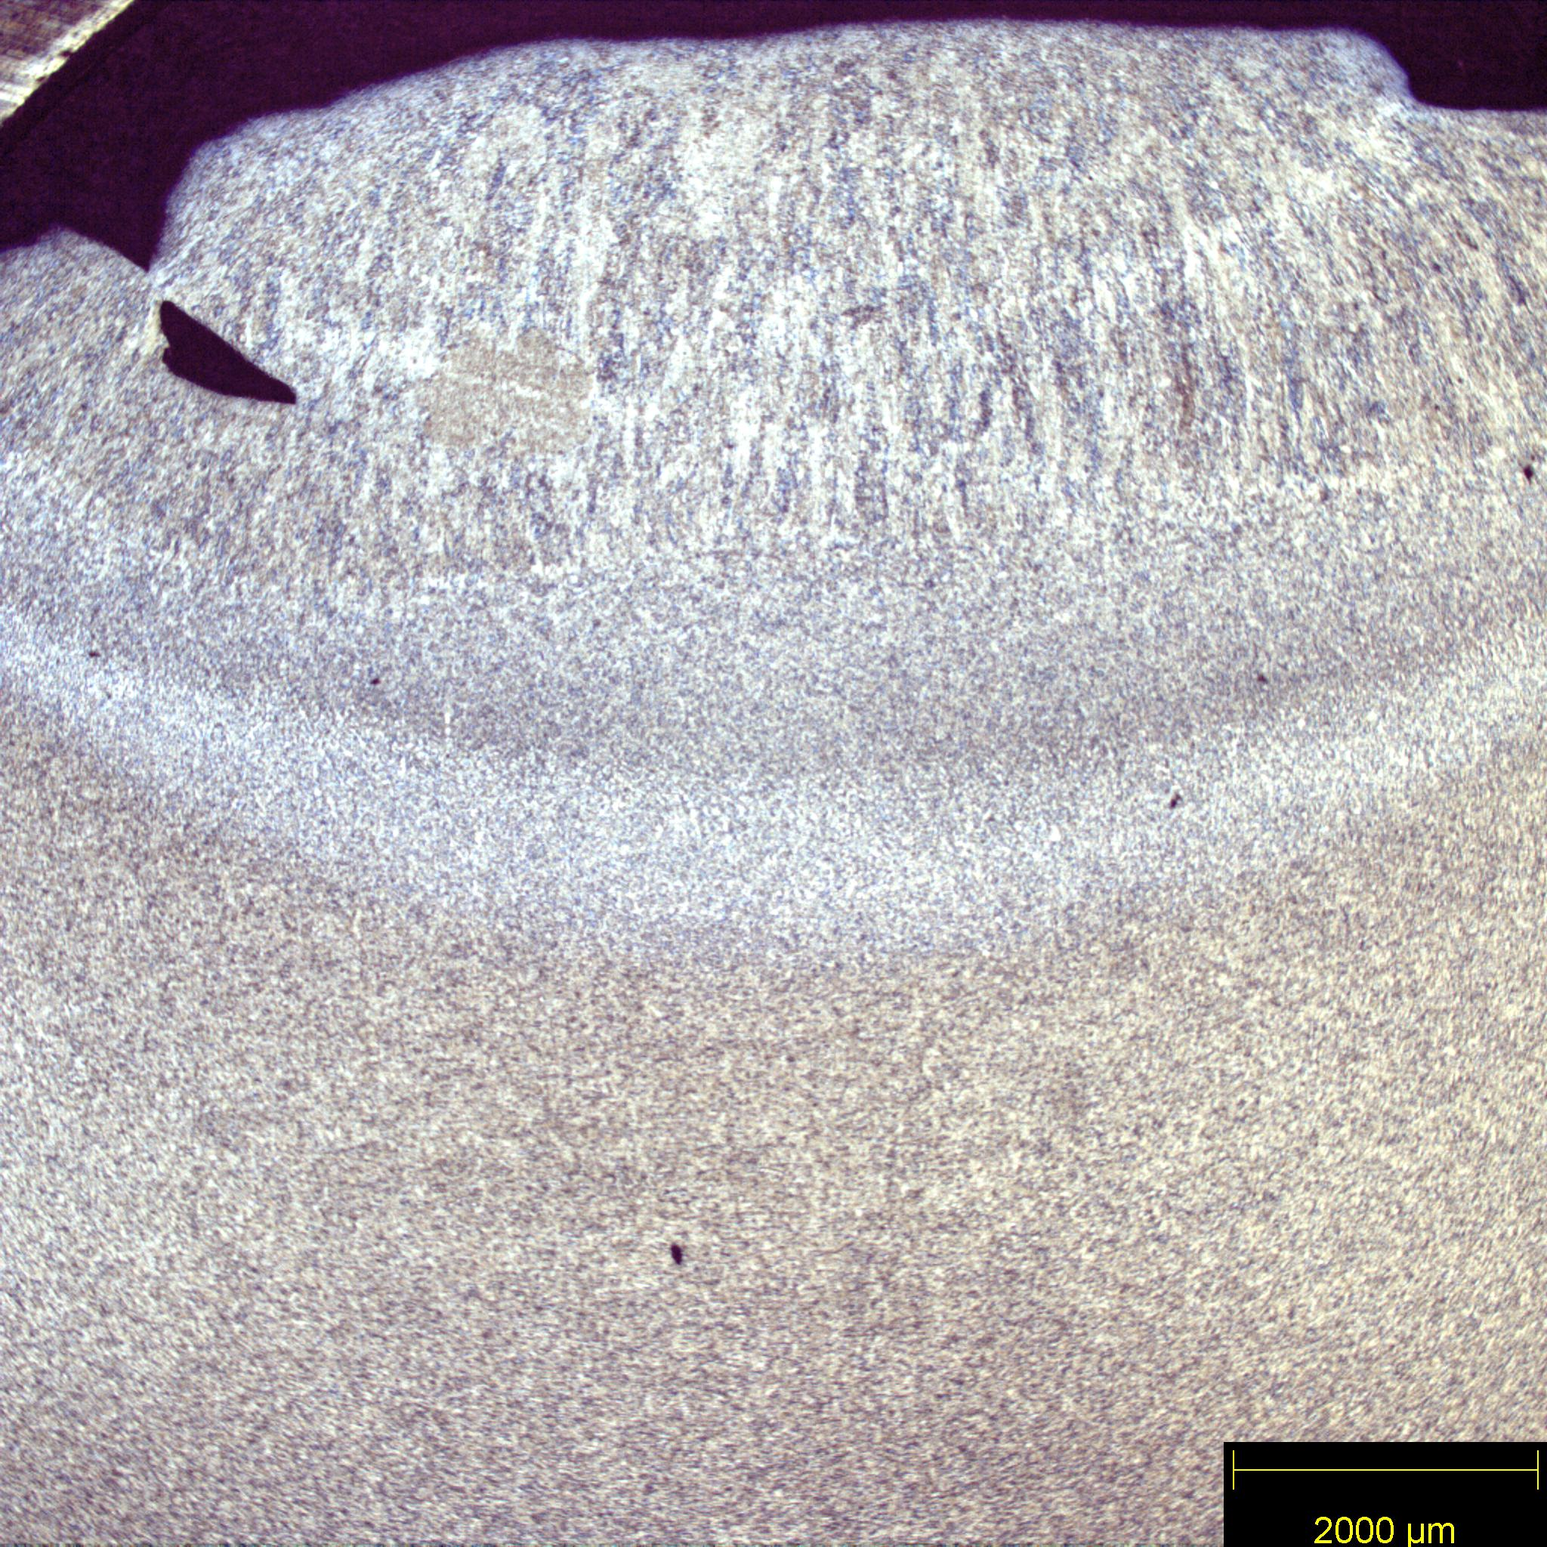

Fusion Zone

Base Metal

Intercritical HAZ

Fine Grain HAZ

Coarse Grain HAZ

*Figure 1: E6010 fusion zone microstructure taken with the 1.25X objective showing the solidification structure. The solidified weld metal is seen at the top of the image with the vertical dendrites. The fusion zone, the three distinct HAZs, and base metal can all be seen clearly.*

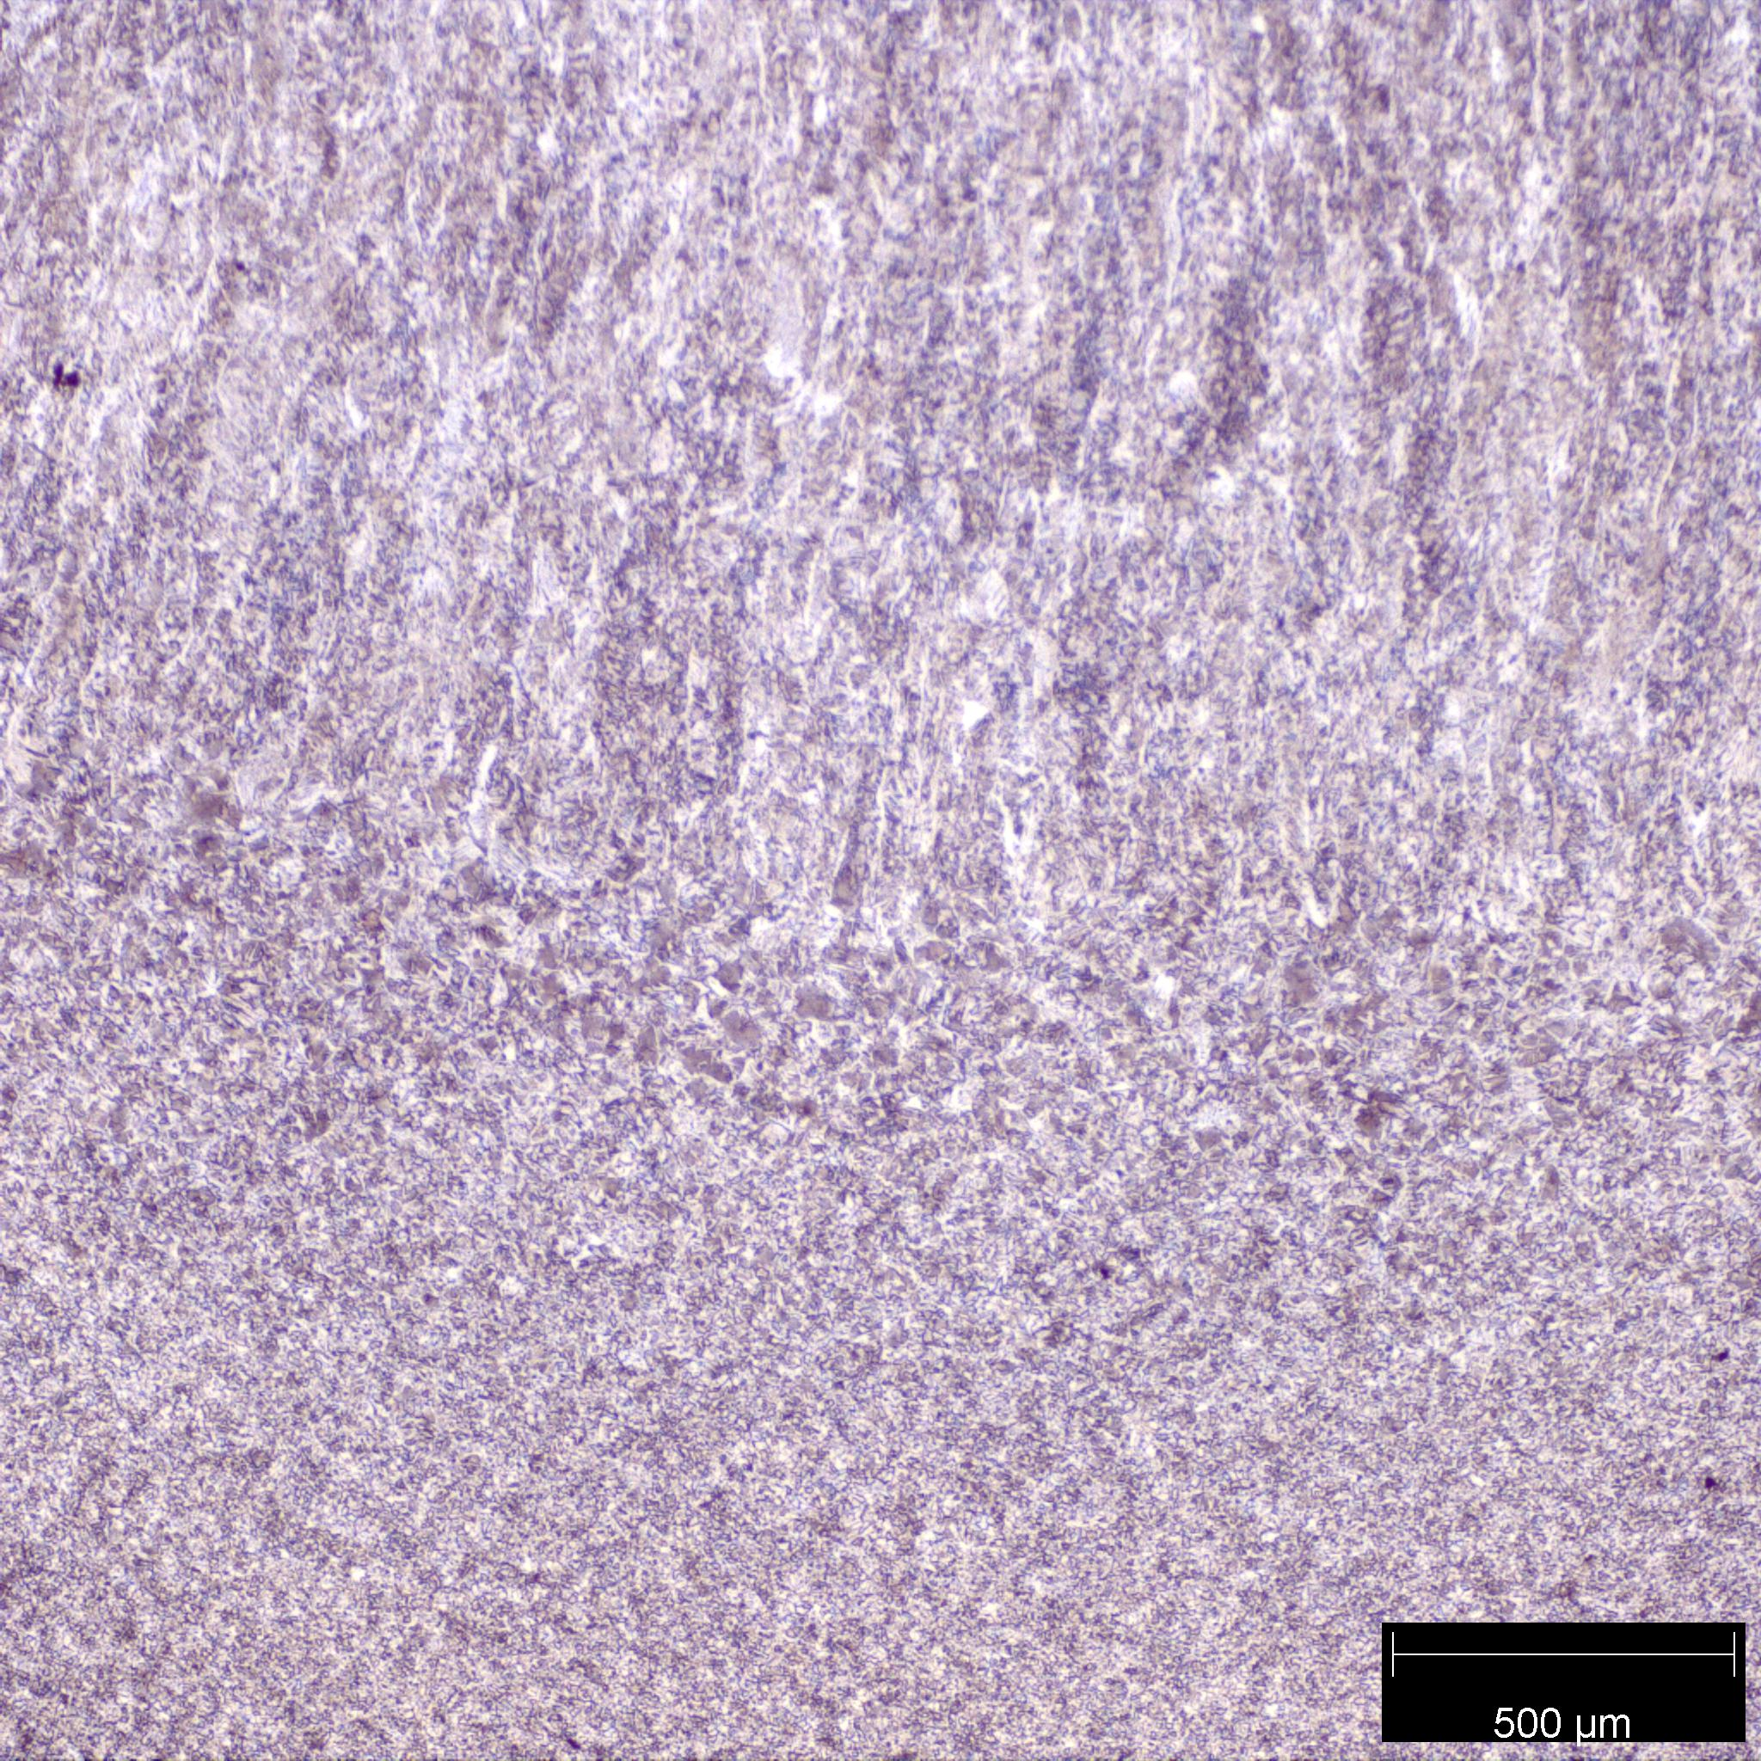

Fusion Line

*Figure 2: Fusion line of the 1018 steel sample welded with an E6010 electrode. The 5X objective was used for this micrograph. The fusion line can be seen where the vertically aligned primary ferrite ends, and the coarse grain HAZ begins.*

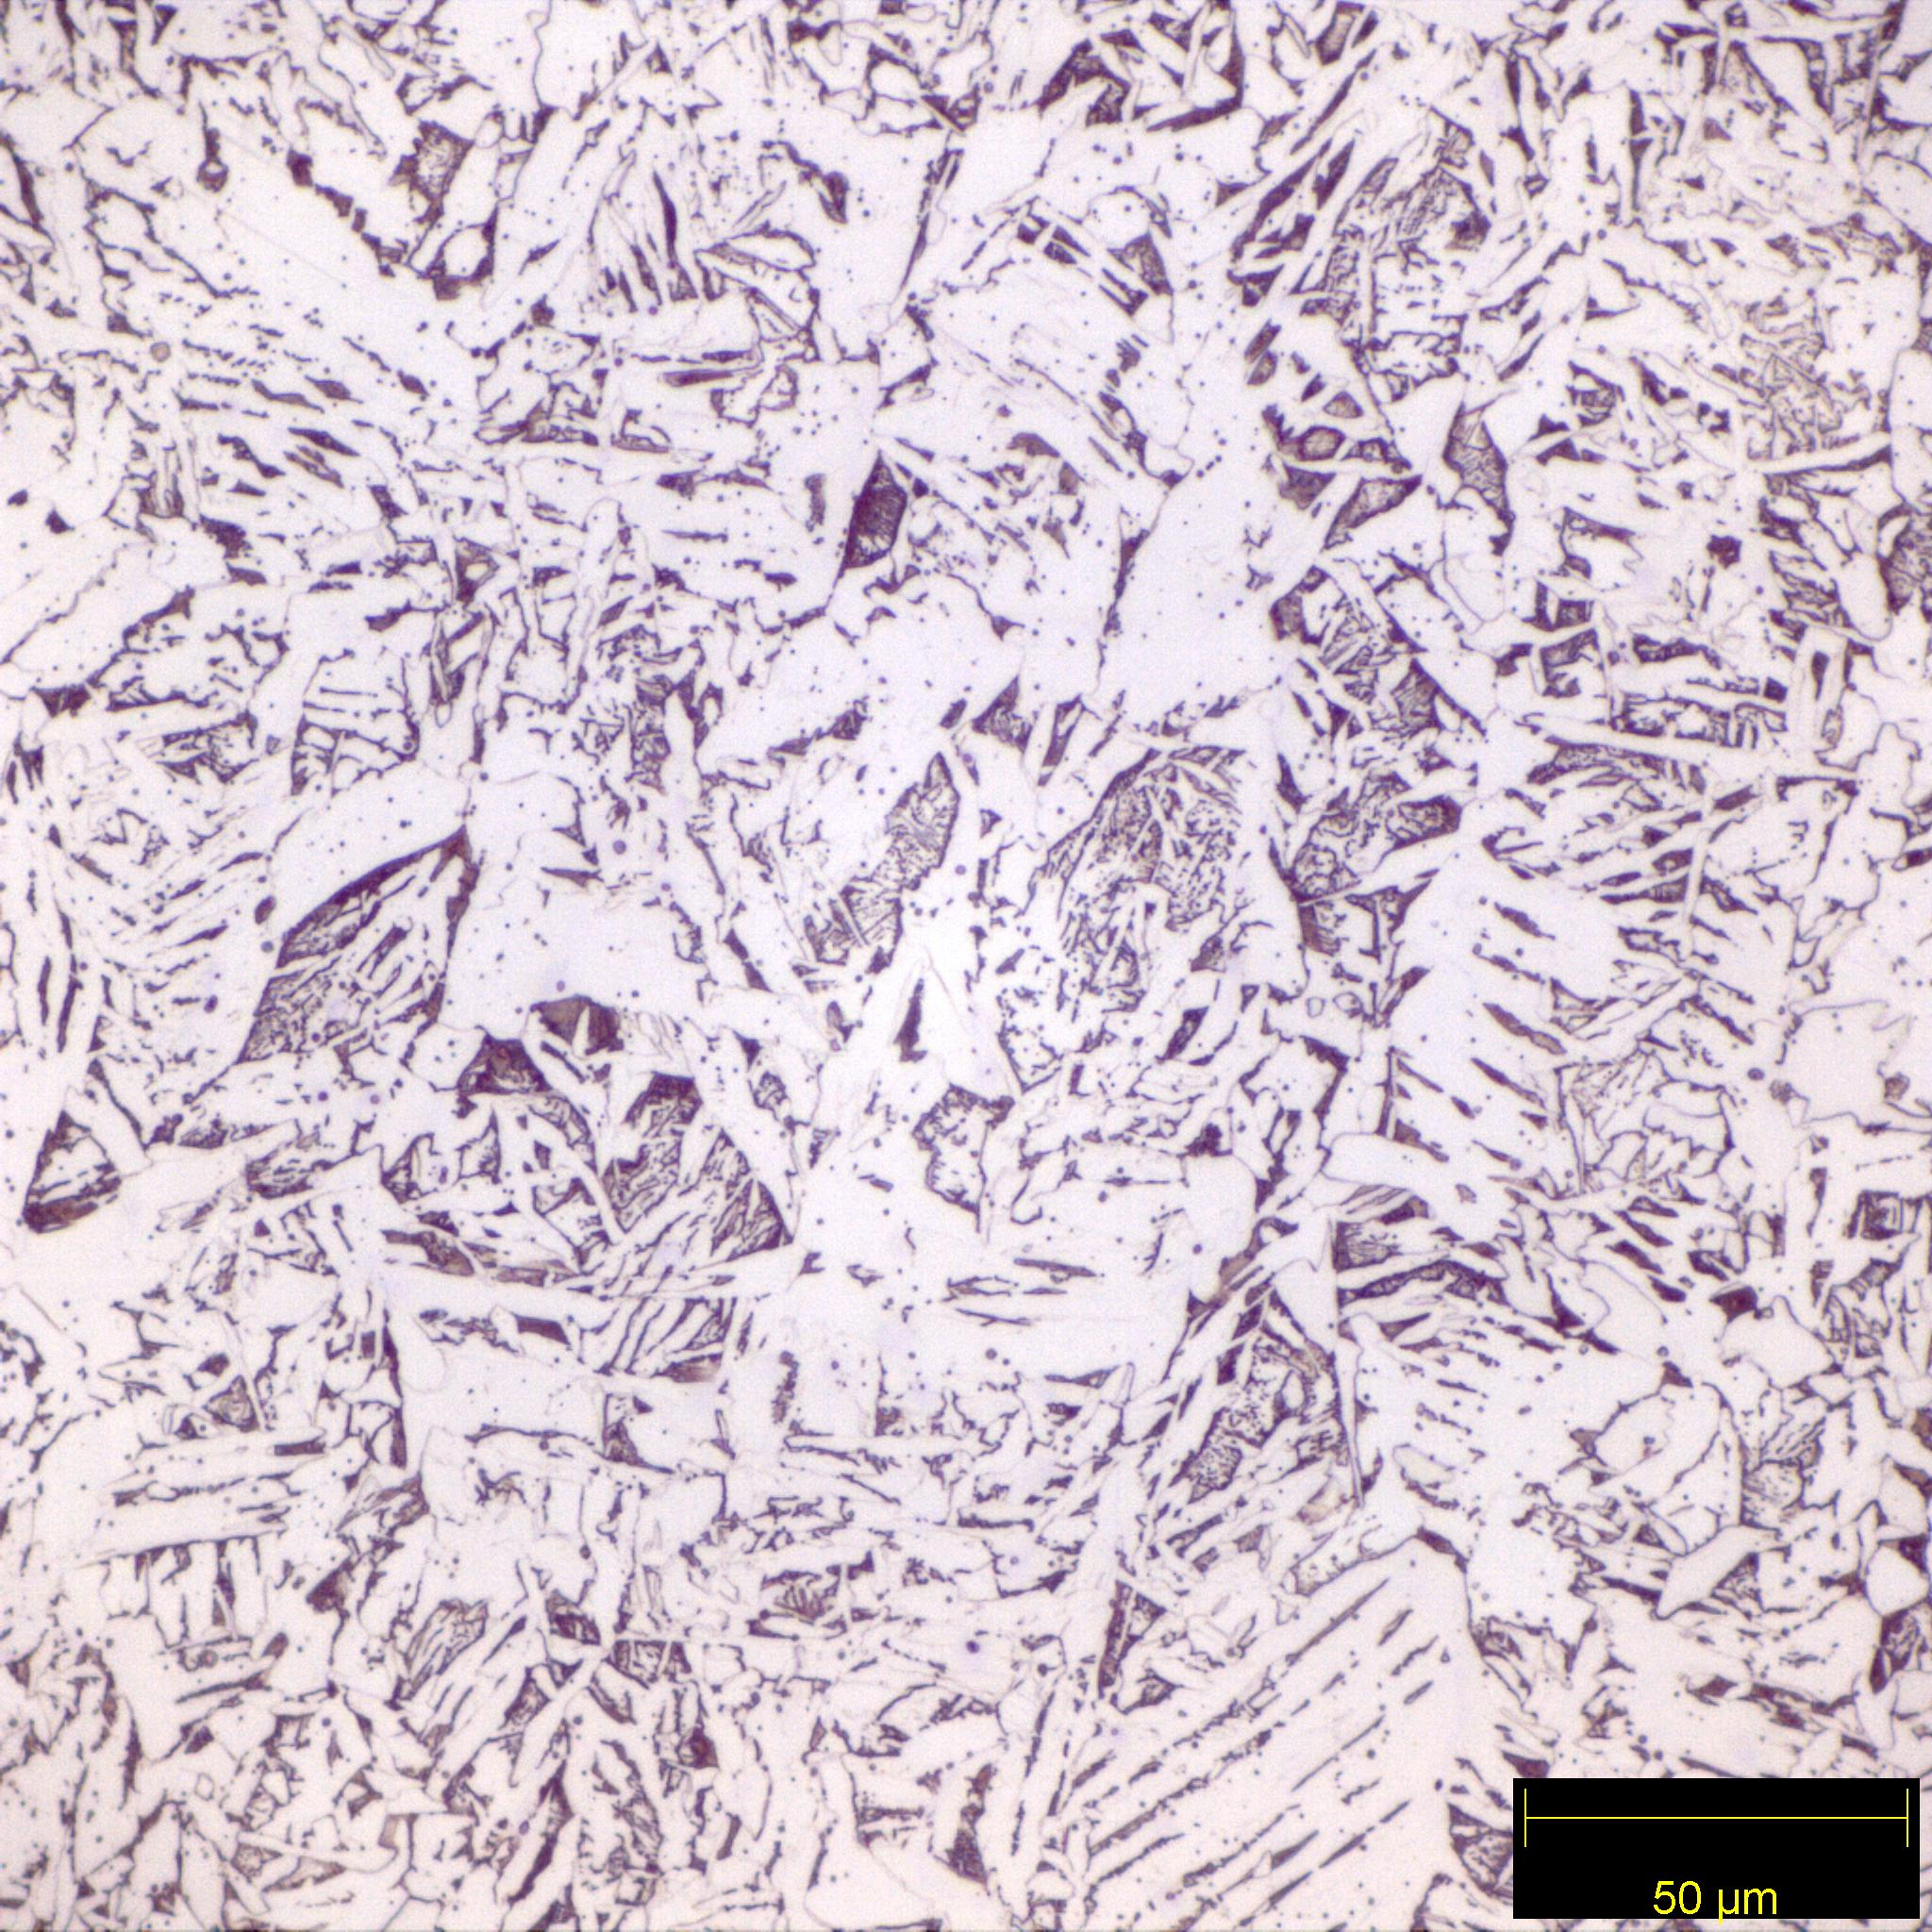

FC(P)

PF(G)

FS(A)

FS(SP)

*Figure 3: E6010 fusion zone microstructure in 1018 steel taken with the 50X objective. Primary grain boundary ferrite, PF(G), forms along a previous grain boundary. Secondary ferrite forms off primary grain boundary ferrite. Secondary ferrite with side plates, FS(SP), has short, wide finger-like structures, compared to secondary ferrite with aligned phase, FS(A). FS(A) presents with long, thin finger-like structures forming off the Primary ferrite. Pearlite, FC(P), can be seen between the fingers of either of the secondary ferrites as a dark purple color.*

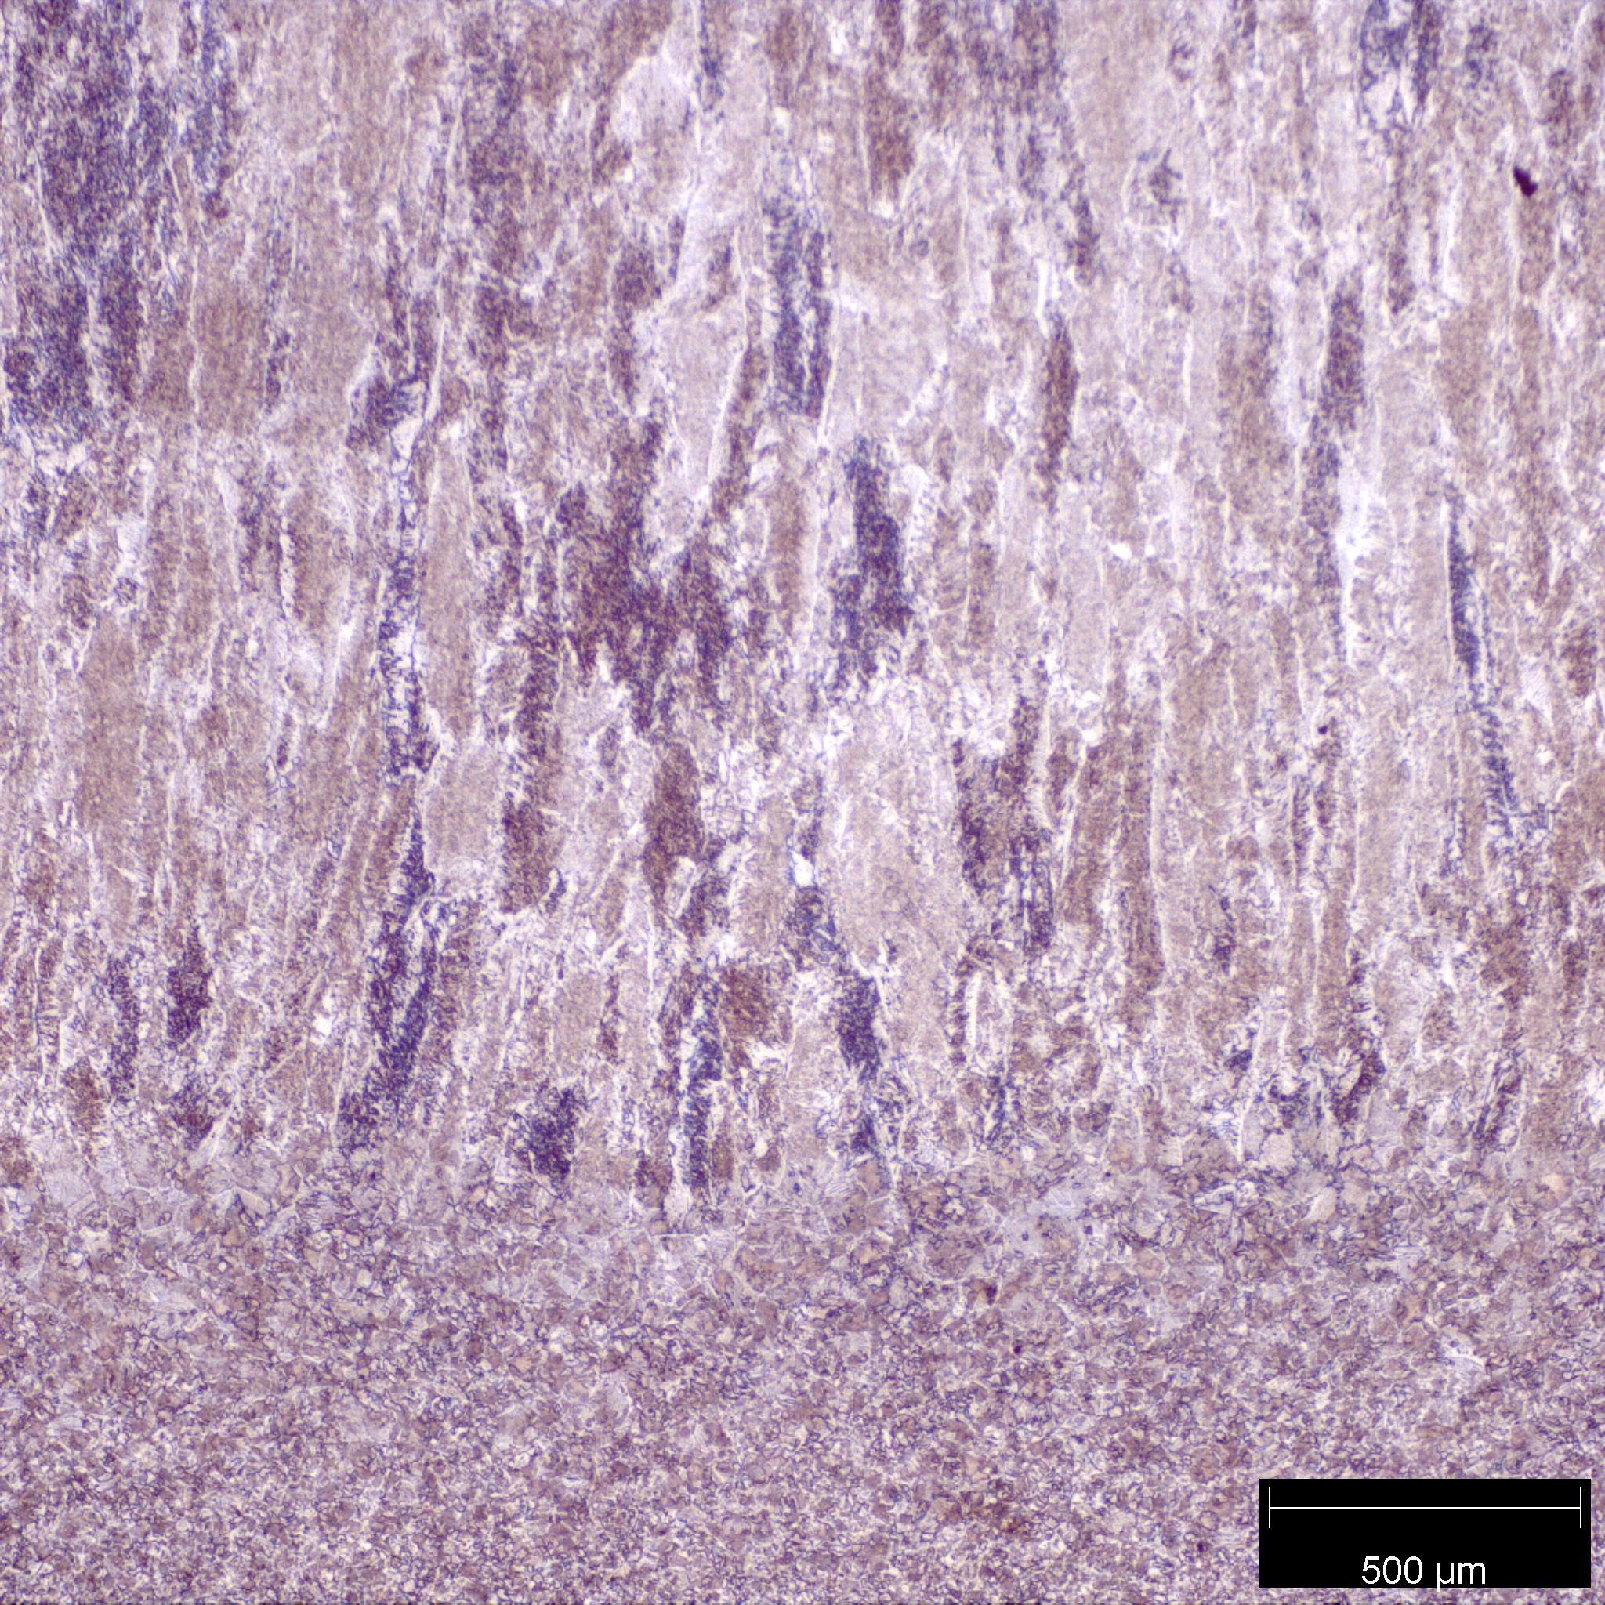

Fusion Line

gfh

gfh

gfh

gfh

*Figure 4: Fusion line of the 1018 steel sample welded with an E7018 electrode. The 5X objective was used for this micrograph. The fusion line can be seen where the vertically aligned primary ferrite ends, and the coarse grain HAZ begins.*

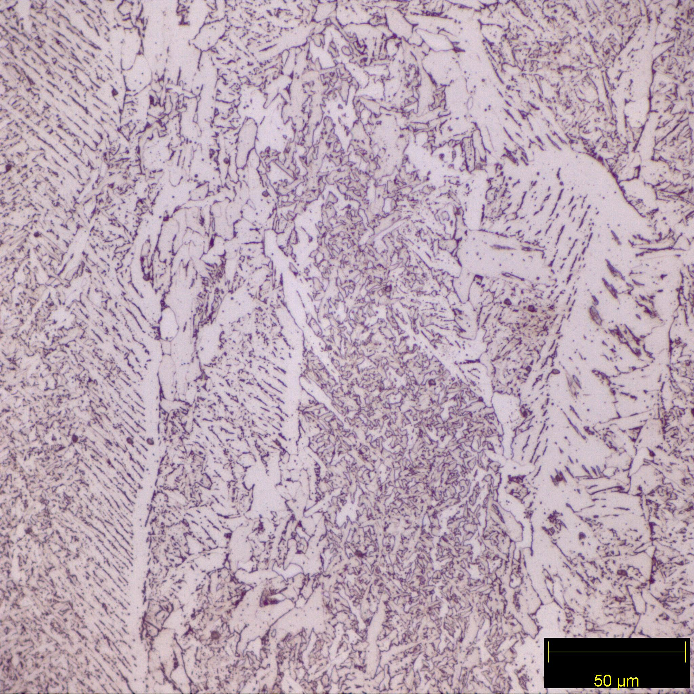

FC(P)

FS(A)

FS(SP)

PF(G)

AF

*Figure 5: E7018 fusion zone microstructure in 1018 steel taken with the 50X objective. Primary grain boundary ferrite, PF(G), forms along a previous grain boundary. Secondary ferrite forms off primary grain boundary ferrite. Secondary ferrite with side plates, FS(SP), has short, wide finger-like structures, compared to secondary ferrite with aligned phase, FS(A). FS(A) presents with long, thin finger-like structures forming off the Primary ferrite. Pearlite, FC(P), can be seen between the fingers of either of the secondary ferrites as a dark purple color. Acicular ferrite, AF, is all the fine lathes with a length-to-width ratio of less than 3:1*

|  |  |  |
| --- | --- | --- |
| **Number** | **Vickers Hardness** | **Distance (um)** |
| 1 | 177 | 0 |
| 2 | 178 | 250 |
| 3 | 174 | 500 |
| 4 | 172 | 750 |
| 5 | 162 | 1000 |
| 6 | 164 | 1250 |
| 7 | 165 | 1500 |
| 8 | 149 | 1750 |
| 9 | 145 | 2000 |
| 10 | 149 | 2250 |
| 11 | 147 | 2500 |
| 12 | 158 | 2750 |
| 13 | 204 | 3000 |
| 14 | 198 | 3250 |
| 15 | 232 | 3500 |
| 16 | 237 | 3750 |
| 17 | 235 | 4000 |

*Table 1: 1018 steel microhardness traverse moving away from fusion line*

|  |  |
| --- | --- |
| 6010 | 7018 |
| 86 | 88.5 |
| 84 | 91 |
| 81.5 | 91.8 |
| 84.3 | 90.4 |
| 84.2 | 90 |
| avg. 84 | avg. 90.3 |

*Table 2: 6010 and 7018 fusion zone macrohardness in Rockwell B scale*

*Figure 6: 1018 Steel Microhardness Traverse Data Visualized*

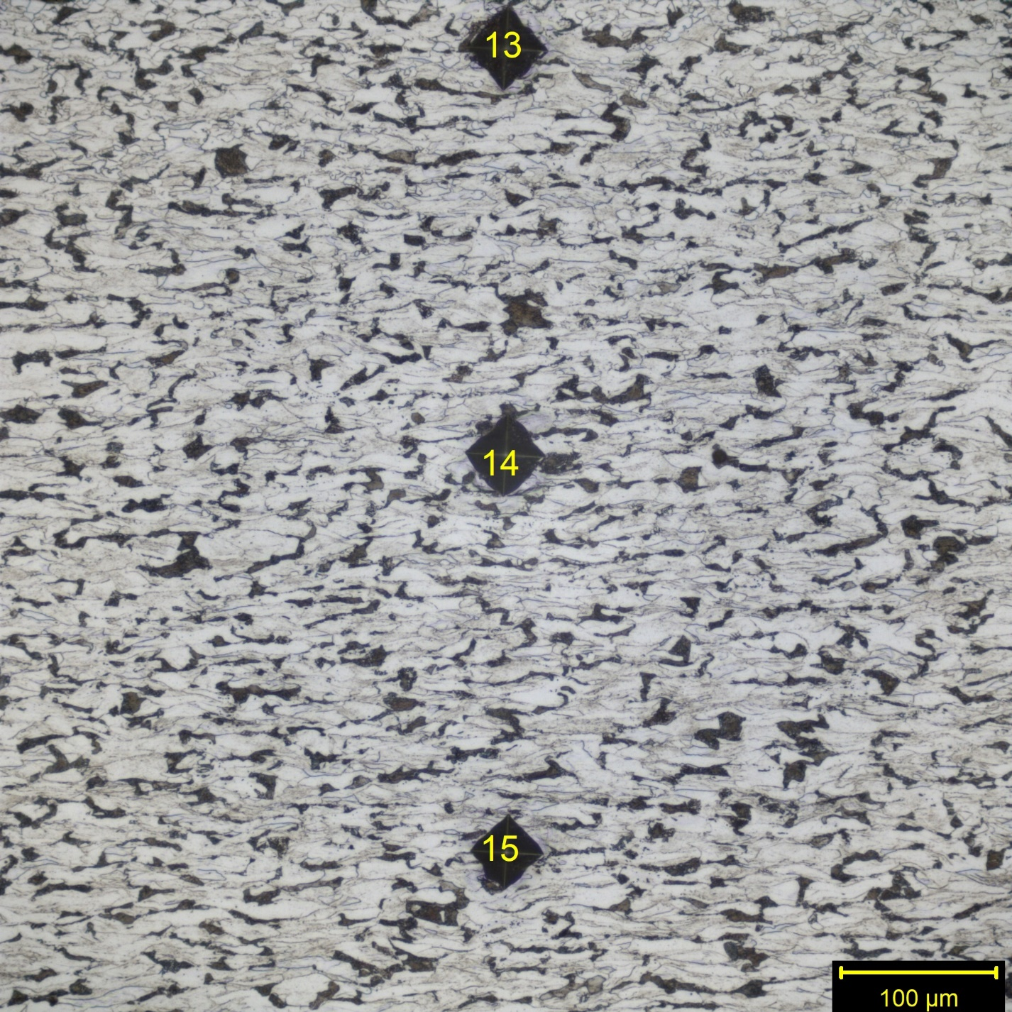

*Figure 7: Micrograph of a 1018 steel HAZ taken with the 25X objective. The microstructure shown is a part of the unaffected base metal. Ferrite can be seen in white, and pearlite in the darker color. The grains are horizontally biased due to a rolling treatment.*

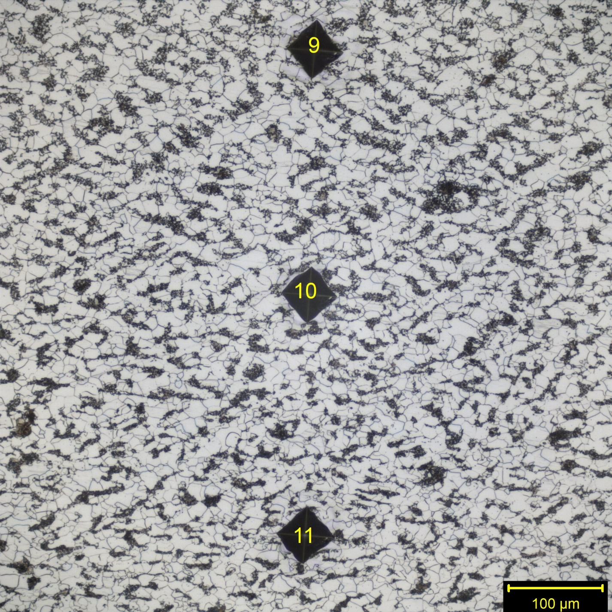

*Figure 8: Micrograph of a 1018 steel HAZ taken with the 25X objective. The microstructure shown is a part of the Intercritical region of the HAZ. Little pearlite transforms into austenite, causing recrystallization upon cooling. This recrystallization is shown by the feathered pearlite. Ferrite can be seen in white, and feathered pearlite in the darker color and the grains are equiaxed.*

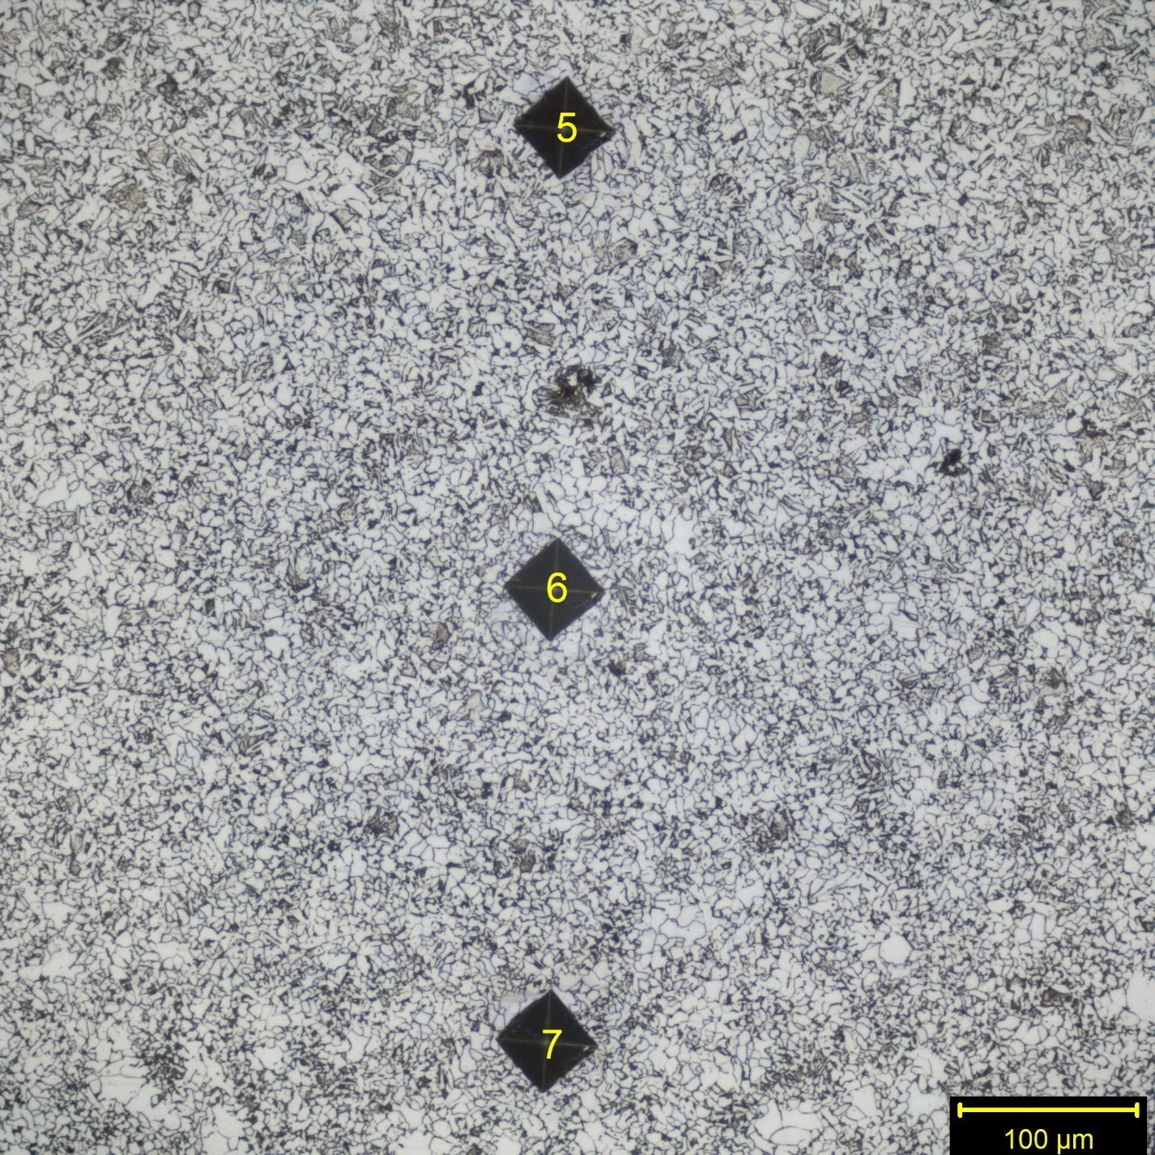

*Figure 9: Micrograph of a 1018 steel HAZ taken with the 25X objective. The microstructure shown is a part of the fine grain HAZ. The ferrite and pearlite both reach their transformation temperature and upon recrystallization fine grain pearlite and fine grain ferrite can be seen in the dark and light color, respectively. The grains are equiaxed.*

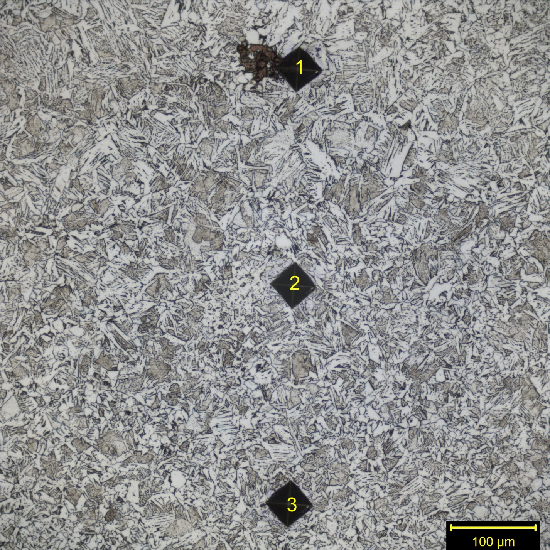

*Figure 10: Micrograph of a 1018 steel HAZ taken with the 25X objective. The microstructure shown is a part of the coarse grain HAZ. The ferrite and pearlite both reach their transformation temperature and upon recrystallization, coarse grain pearlite and coarse grain ferrite are present. Coarse grain ferrite can be seen in white, and coarse grain pearlite in the darker color.*

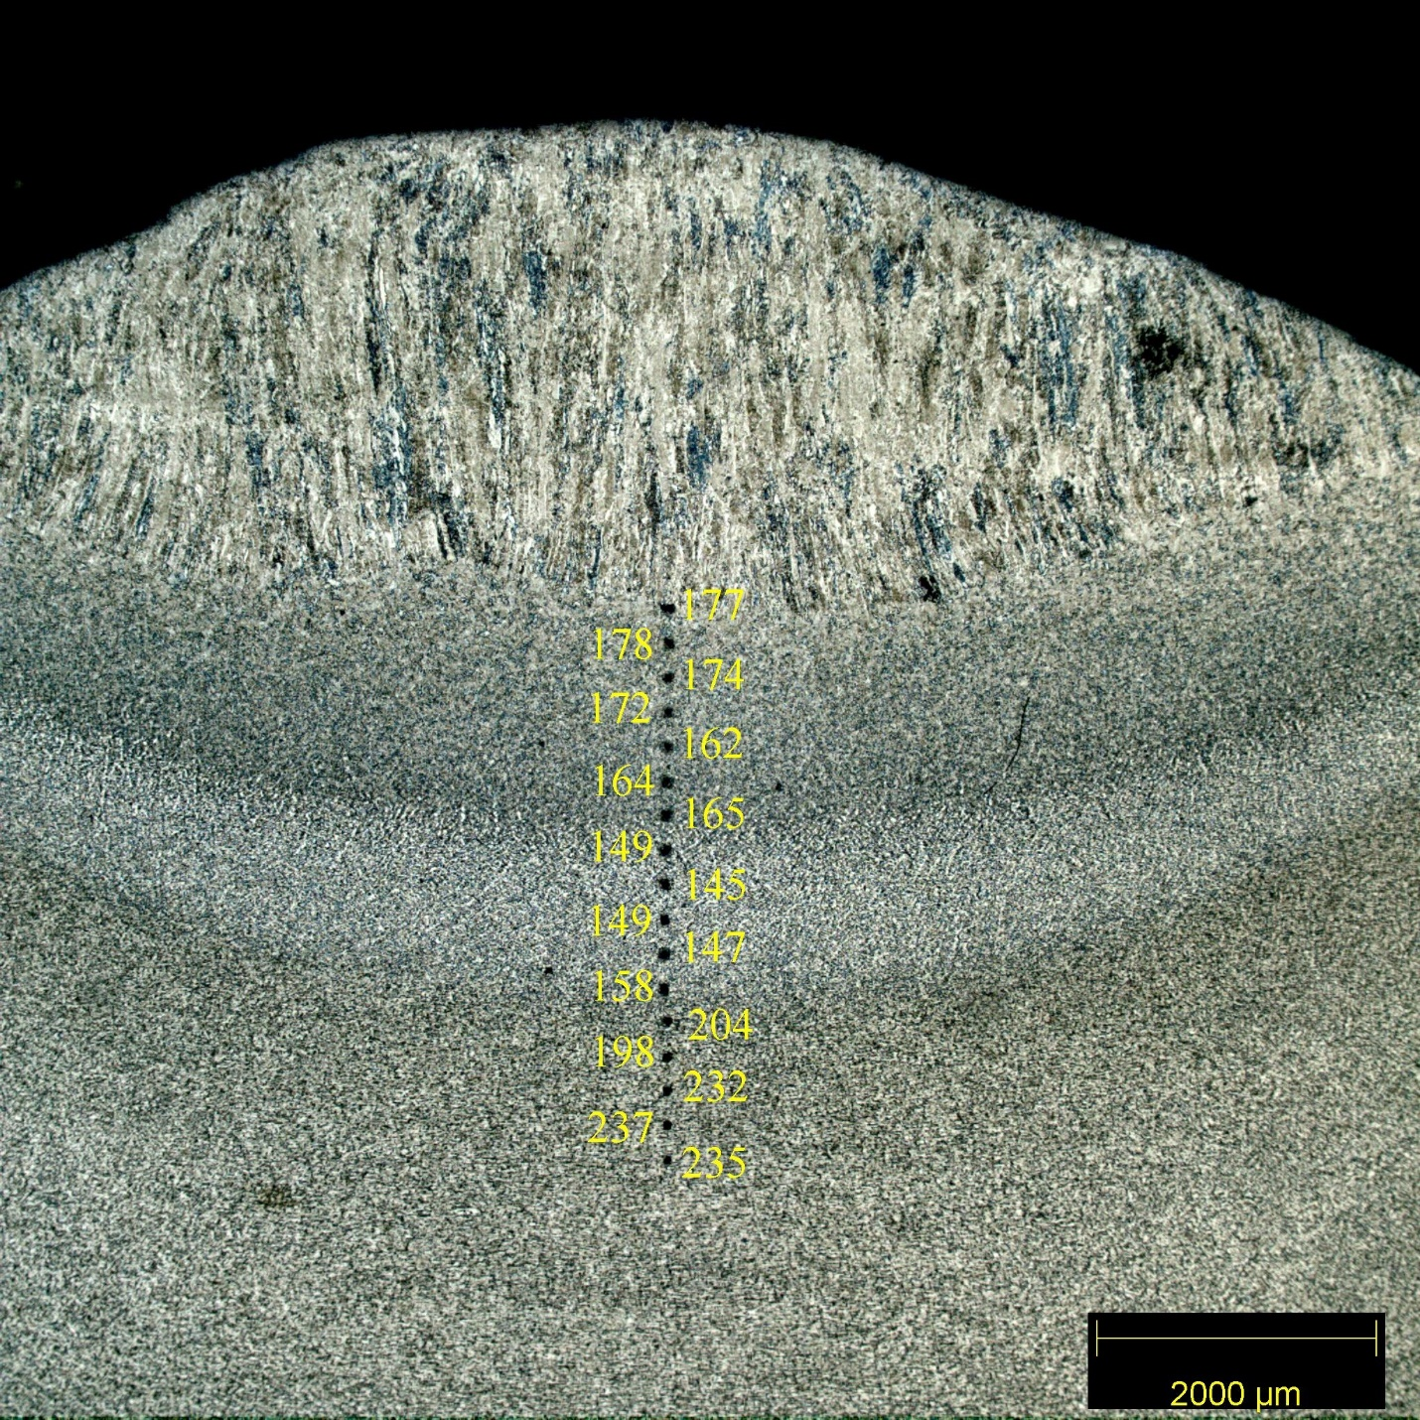

*Figure 11: Micrograph of the entire microhardness traverse with Vickers hardness data shown next to their respective indents*

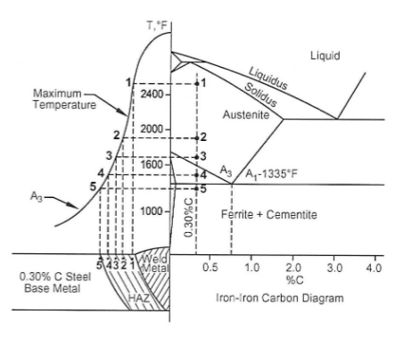

*Figure 12: HAZ temperatures mapped onto an Iron-Iron Carbide diagram*

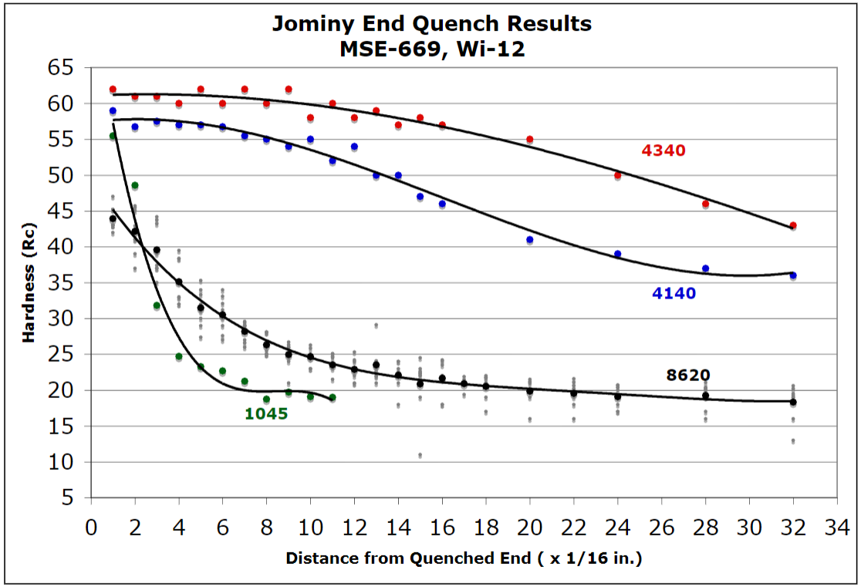

*Figure 13: Jominy end quench results. No 1018 data is present, however, the 1045 shows the same pattern.*

**Discussion**

The fusion line of the E6010 and E7018 electrodes can be seen where the vertically aligned grains of the fusion zone meet the coarse grain HAZ (Figures 2 and 4). Above this line is the fusion zone. The fusion zone of the E6010 electrode on the 1018 steel as seen in Figure 3 has primary grain boundary ferrite, secondary ferrite with side plates, secondary ferrite with aligned phase, and pearlite present. As the molten weld metal cools, the primary grain boundary ferrite forms. Then secondary ferrite forms off the primary grain boundary ferrite in a perpendicular manner. Pearlite forms next. The 0.12wt.% C in the E6010 fusion zone allows for ample pearlite formation. Due to the etchant used, the white in the micrograph is ferrite, but the dark color is not always pearlite (Figure 3). The place where pearlite always forms is between the side plates of the secondary ferrite.

The fusion zone of the E7018 electrode contains all the microstructures of the E6010 electrode—primary grain boundary ferrite, secondary ferrite with side plates, secondary ferrite with aligned phase, and pearlite—along with acicular ferrite (Figure 5). Primary and secondary ferrite is identified in the same way as the E6010. Due to the 0.045wt.% C in the E7018 compared to the 0.12wt.% C in the E6010 the only pearlite that forms is between the side plates of the secondary ferrite. None will form outside of that region.

The average hardness of the E6010 and E7018 fusion zones are 84 and 90.3 on the Rockwell B scale even though E6010 fusion zone contains significantly more pearlite (Table 2). The E7018 fusion zone is harder due to additions of 1.10wt.% Mn and 0.40wt.% Si, which have the by design. The less carbon in the E7018 fusion zone there is, the more ferrite will form. The E7018 has alloying elements that promote acicular ferrite to form, and this form of ferrite is the main reason the E7018 weld metal requires 146 extra ft.-lbs. of force to fail during the Charpy V-notch test.

The HAZs for this experiment were deemed similar enough to be analyzed just once for both the E6010 and E7018 electrodes. The regions of the HAZ can be seen visually in Figure 1, and in the microhardness traverse data. The microhardness data shows 177 Vickers close to the fusion line, dipping down as distance from the weld increased, and a sharp jump up to 230 Vickers at around 3500um from the fusion line (Table 1). This data is visualized in Figure 6 and 11. The dip in hardness can be explained by the Jominy end quench data (Figure 13). The areas that experience the steepest cooling rates will become harder than those areas that cooled at a shallower rate. The reason that the microhardness traverse hardness goes up to 232 Vickers at indent 15 is because the 1018 steel was initially cold-rolled, and at 3500um away from the fusion line the heat of welding had no impact on the cold-rolled grains.

Indents 13-15 show no sign of recrystallization (Figure 7), as they still have grains that are stretched horizontally from cold-rolling. The hardness in this area is 232, 237, and 235 Vickers for indents 13-15. This area is in the area that has base metal not impacted from welding (Figure 1). Indents 9-11 are in the intercritical HAZ. This area reached temperatures hot enough to only transform pearlite to austenite, and upon cooling reforms as a finer grain pearlite with a feathered appearance (Figures 8 and 12). This region lost the effects of cold-rolling, as can be seen by the equiaxed grains, and the microhardness readings of 145, 149, and 147 for indents 9-11(Figure 8 and Table 1).

Indents 5-7 take place in the fine grain HAZ. This region completely transformed into austenite (Figure 12) but did not go very far into the austenite region, resulting in fine grains of pearlite and ferrite upon cooling. The fine grain HAZ cooled more rapidly than the intercritical HAZ so it is harder. The Vickers microhardness data of 162, 164, and 165 for indents 5-7 (Figure 9 and Table 1), along with the Jominy end quench data supports this (Figure 13). Indents 1-3 occur the closest to the fusion zone. This region immediately next to the fusion zone is known as the coarse grain HAZ due to the large grains that form (Figure 10). The large grains form because the peak temperature in this region is very close to the melting point (Figure 12). The coarse grain HAZ cools with the fastest rate and has the hardest microstructure despite having larger grains that the other parts of the HAZ (Table 1). The Jominy end quench data agrees with this (Figure 13).

**Conclusion**

Both the E6010 and E7018 form primary and secondary ferrite, however due to the E7018 fusion zone containing less carbon, pearlite forms less readily. The E6010 fusion zone has a hardness of 84 Rockwell B due to the 0.12wt.% (Table 2). The E7018 fusion zone has a hardness of 90.3 Rockwell B due to the addition of 1.10wt.% Mn and 0.40wt.% Si. Acicular ferrite formation in the E7018 fusion zone causes the toughness to be higher than the E6010 fusion zone with a Charpy V-notch toughness of 168 and 22 ft.-lbs. respectively.

Welding adds a significant amount of heat to the part, which will undo cold-working in the HAZ. As the peak temperature of the HAZ increased, the distance to the fusion zone decreased. As a result, different regions of the HAZ could be identified (Figure 1). The intercritical HAZ only got hot enough to undo the cold working and to cause feathered pearlite to form upon cooling. The fine grain HAZ achieved a full austenitic transformation (Figure 12) but didn’t go very far into the austenite transformation region, which led to fine grains to form upon cooling. The coarse grain HAZ got the hottest, which led to large grains of pearlite and ferrite to form upon cooling. The grain size itself was not the largest factor in microhardness, however the faster cooling rate of the HAZ closer to the fusion zone caused an increase in hardness. This is can be seen in the Jominy end quench data (Figure 13).